COMING SOON EMAIL TEMPLATE

Dear Tenant,

We're thrilled to announce that our newest building amenity, the Minnow Pickup Pod™, will soon be available.

WHAT IS IT?

The Minnow Pickup Pod is a safe and convenient way to have restaurant meals delivered. It’s like an Amazon locker, only designed for food. Instead of meeting the delivery person for a face-to-face exchange, you can have your food delivered to the pod and pick it up whenever it’s convenient. You don’t even have to be in the building when your food is delivered—it will be kept in a secure, insulated cubby until you’re ready to pick it up.

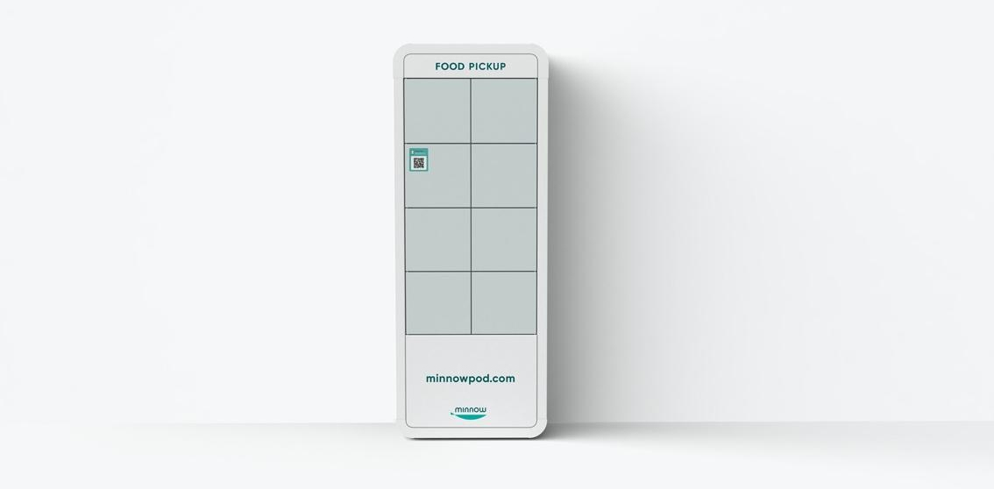

HOW DOES IT WORK?

You can use the pod for food delivered by any food delivery app or local restaurant. However, the pod should not be used for grocery deliveries or food delivered through the mail or UPS/Fedex, like Blue Apron or Hello Fresh.

To have food delivered to the pod, just include your Minnow key in the delivery instructions. Your Minnow key is a four-letter code you get when you create your free Minnow account. If you use a delivery app like DoorDash or Uber Eats, just add your Minnow key to the delivery instructions in your DoorDash or Uber Eats profile and you’ll never have to think about it again.

When your order is delivered, you’ll get text and email notifications with instructions on how to pick it up. You have up to 2 hours to pick up your order.

HOW DO I SIGN UP?

When the Pickup Pod is installed in the lobby and ready to use, we’ll send you a link to the signup page. Signing up is fast, easy, and free.

Please let us know if you have any questions.

Thank you,

Property Management Team

